Implementation of Shift-Reduce Parser

AIM
To write a C program to implement a Shift-Reduce Parser for the given grammar and display each SHIFT, REDUCE and ACCEPT operation performed while parsing the input string.
Grammar:
- E → E + T
- E → T
- T → id

ALGORITHM
- Start the program.
- Read the input string.
- Initialize an empty parsing stack.
- Scan the input string from left to right.
- Perform SHIFT operation to move input symbols onto the stack.
- Apply REDUCE operation whenever a grammar production matches.
- Replace id with T.
- Replace T with E.
- Reduce E + T to E.
- If the stack contains only E and the input is completely consumed, perform ACCEPT.
- Otherwise, perform REJECT.
- Stop the program.

PSEUDOCODE
START
Read input string
Initialize stack
Set top = -1

WHILE input is not empty
SHIFT input symbol onto stack

IF top of stack is id
REDUCE T → id
END IF

IF stack contains E + T
REDUCE E → E + T
ELSE IF top of stack is T
REDUCE E → T
END IF
END WHILE

IF stack contains only E
Display ACCEPT
ELSE
Display REJECT
END IF
STOP

PROGRAM
#include <stdio.h>
#include <string.h>

int main()
{
char input[100];
char stack[100][10];
int top = -1, i = 0;

printf("Enter input string: ");
scanf("%s", input);

printf("\nSTACK\t\tINPUT\t\tACTION\n");

while (1)
{
// SHIFT
if (input[i] != '\0')
{
if (input[i] == 'i' && input[i+1] == 'd')
{
strcpy(stack[++top], "id");
i += 2;
}
else if (input[i] == '+')
{
strcpy(stack[++top], "+");
i++;
}
else
{
printf("REJECT\t\t$\t\tInvalid String\n");
return 0;
}

printf("SHIFT\t\t%s\t\tSHIFT\n", input + i);
}

// REDUCE: T → id
if (top >= 0 && strcmp(stack[top], "id") == 0)
{
strcpy(stack[top], "T");
printf("REDUCE\t\t%s\t\tT -> id\n",
input[i] ? input+i : "$");
}

// REDUCE: E → E + T
if (top >= 2 &&
strcmp(stack[top-2], "E") == 0 &&
strcmp(stack[top-1], "+") == 0 &&
strcmp(stack[top], "T") == 0)
{
top = top - 2;
strcpy(stack[top], "E");

printf("REDUCE\t\t$\t\tE -> E + T\n");
}

// REDUCE: E → T
else if (top >= 0 && strcmp(stack[top], "T") == 0)
{
strcpy(stack[top], "E");

printf("REDUCE\t\t%s\t\tE -> T\n",
input[i] ? input+i : "$");
}

// ACCEPT
if (input[i] == '\0' &&
top == 0 &&
strcmp(stack[top], "E") == 0)
{
printf("ACCEPT\t\t$\t\tACCEPT\n");
break;
}

// REJECT
if (input[i] == '\0')
{
printf("REJECT\t\t$\t\tInvalid String\n");
break;
}
}

return 0;
}

SAMPLE INPUT
id+id

SAMPLE OUTPUT
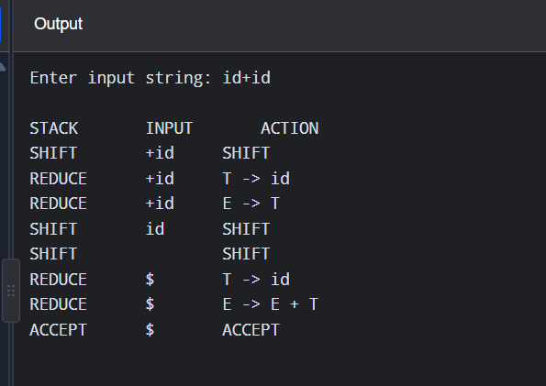
RESULT
Thus, the C program to implement a Shift-Reduce Parser and display SHIFT, REDUCE and ACCEPT operations was successfully executed.

